**HTML 5**

HTML is the **markup language** used for Web pages. HTML is the first thing we need to learn when we want to go into Web Development.

* HTML stands for **Hyper Text Markup Language**
* HTML describes the **structure** of a Web page
* HTML consists of a series of **elements**
* HTML elements tell the browser **how to display the content**

**Editor**

We will be using Notepad++ as our editor.

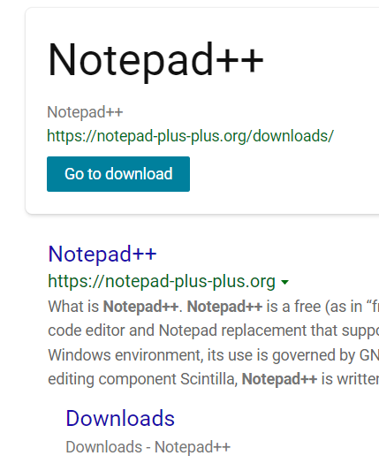

1. *Create a folder and name it WebClass*
2. *Download and install Notepad++*
3. *Open Notepad++*
4. *Type the following lines into Notepad++*

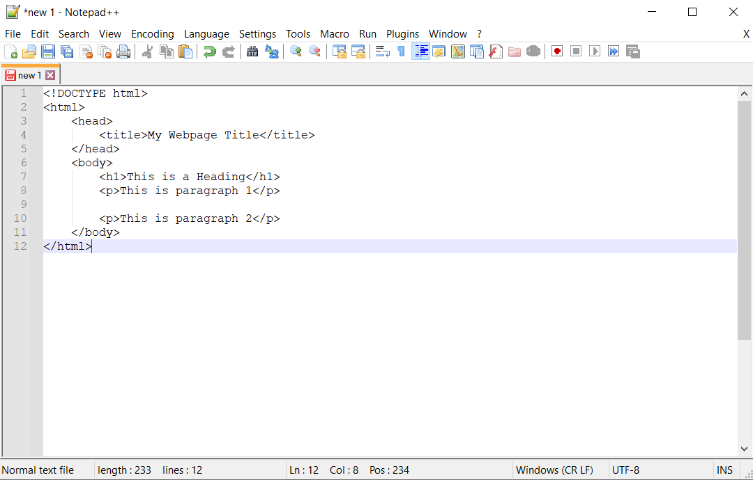

1. *Save the file as index.html in the WebClass folder. Make sure you select the right file type (Hyper Text Markup Language file) as shown below. And note that Notepad++ has so many options for file types.*

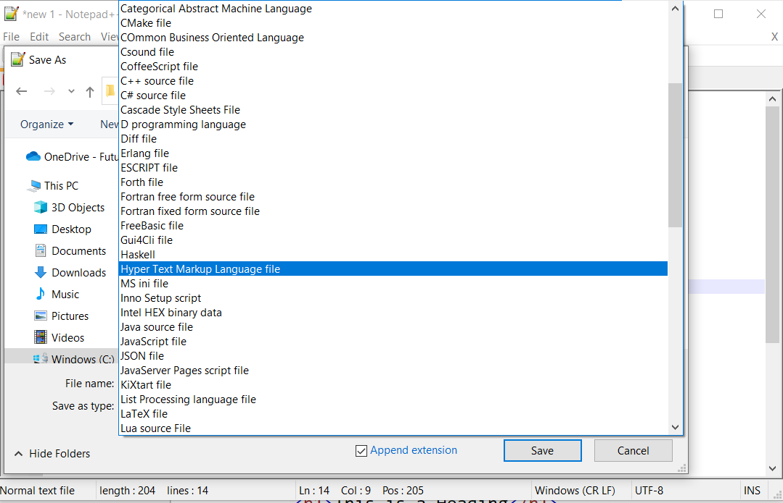

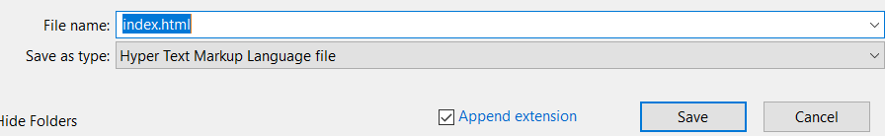

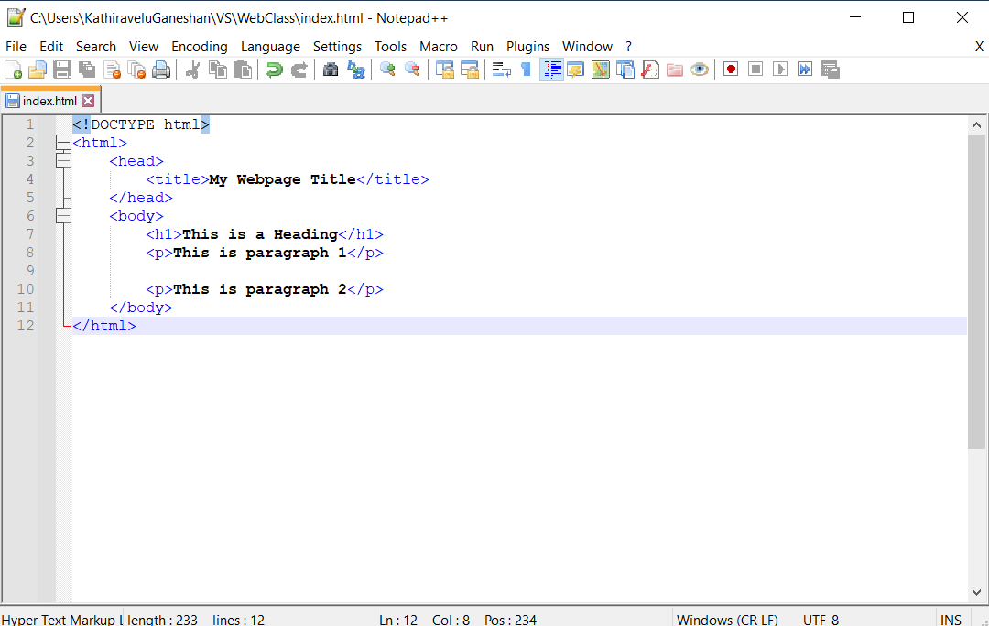

1. *Open the WebClass folder and double click index.html*

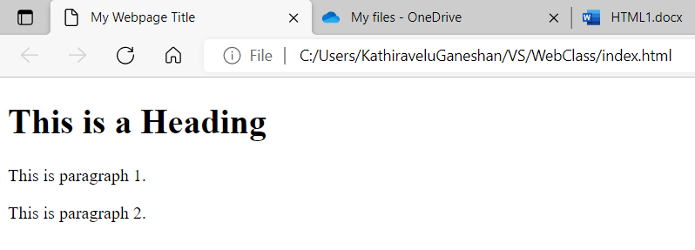

**Let us look at what all these lines mean.**

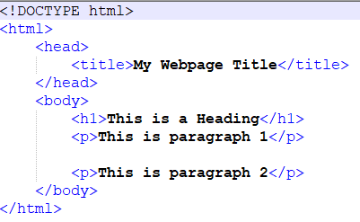

* <!DOCTYPE html> is used to declare this document as an **HTML5 document**
* <html> is the **root element** of the HTML page.
* <head> is the **element** that contains meta information about the HTML page.
* <title> is the **element** used to specify the title for the HTML page. This is the Title shown in the browser's title bar or in the page's tab.
* <body> is the **element** used to define the document's body. This is the container for all the visible contents, such as headings, paragraphs, hyperlinks, images, tables, and lists.
* <h1> is the **element** used to define a large heading. Other options are h2, h3, h4, h5 and h6. h1 is the largest.
* <p> is the **element** used to define a paragraph.

**HTML Elements**

An HTML element is defined by a start tag, some content, and an end tag.

For example, in <h1>This is a Heading</h1>, <h1> is the **start tag**, </h1> is the **end tag** and “This is a Heading” is the **content**.

Note: The <br> tag defines a line break, and is an **empty element** without a closing tag.

**HTML Page Structure**

<html>

<head>  
 <title>My Webpage Title</title>  
 </head>

<body>  
  
 <h1>This is a Heading</h1>

<p>This is paragraph 1</p>

<p>This is paragraph 2</p>  
  
</body>

</html>

**HTML Documents**

All HTML documents must start with a document type declaration: <!DOCTYPE html>.

The HTML document itself begins with the <html> (start tag) and ends with </html> (end tag).

The visible part of the HTML document is between the <body> (start tag) and </body> (end tag).

**Let us create our first website.**

1. *Open the index.html file in Notepad++ and edit as shown below.*

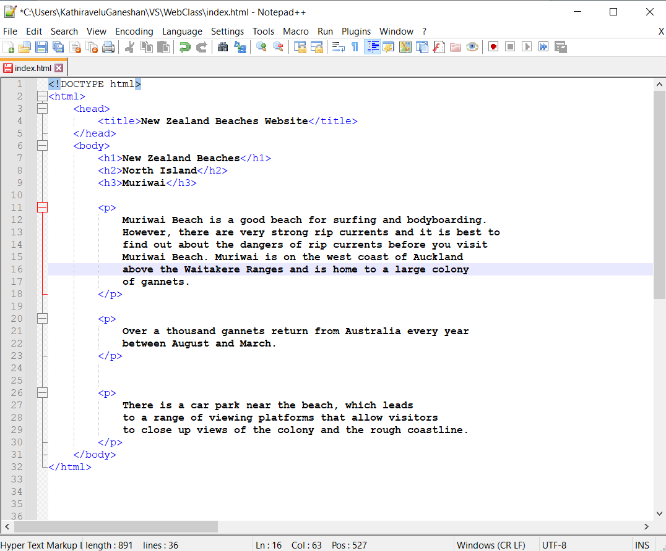

1. *Open the WebClass folder and double click index.html*

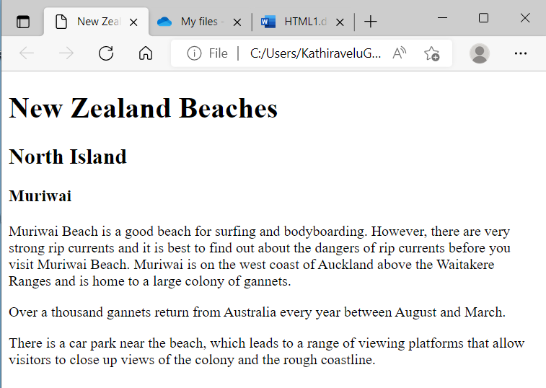

# **HTML Attributes**

HTML **attributes** provide additional information about HTML elements.

* All HTML elements can have **attributes**
* Attributes are always **specified** in the start tag
* Attributes usually come in **name/value pairs** like: name="value"

## **href** Attribute

The **<a>** tag defines a **hyperlink**. The **href** attribute specifies the URL of the page the link refers to.

1. *Open the index.html file in Notepad++ and add*

*<a /href = "https://westauckland.co.nz/beaches/muriwai-beach"/>Muriwai Beach</a>*

*as shown below.*

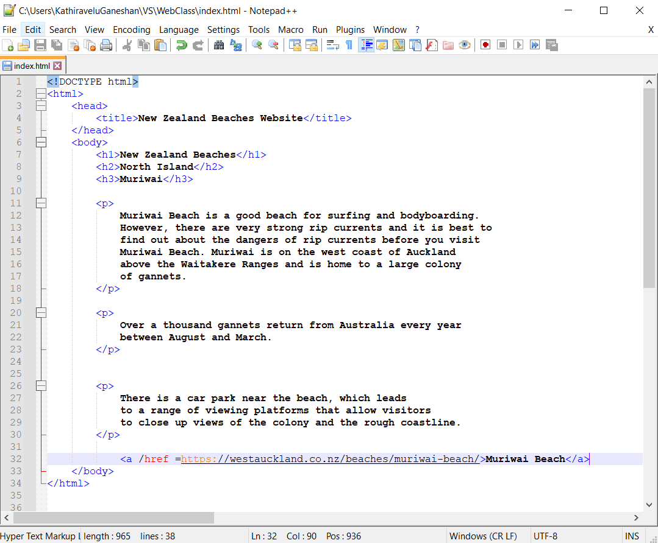

1. *Open the WebClass folder and double click index.html or refesh your website if it is already open.*

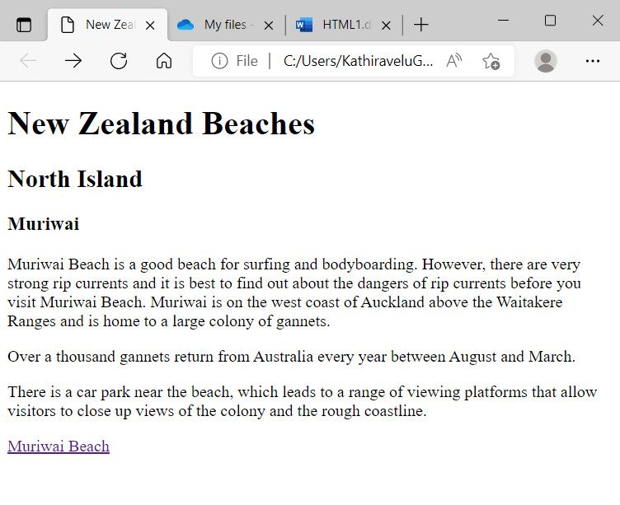

1. *Click on the* ***link*** *“Muriwai Beach” and it will take you to the Muriwai Beach website.*

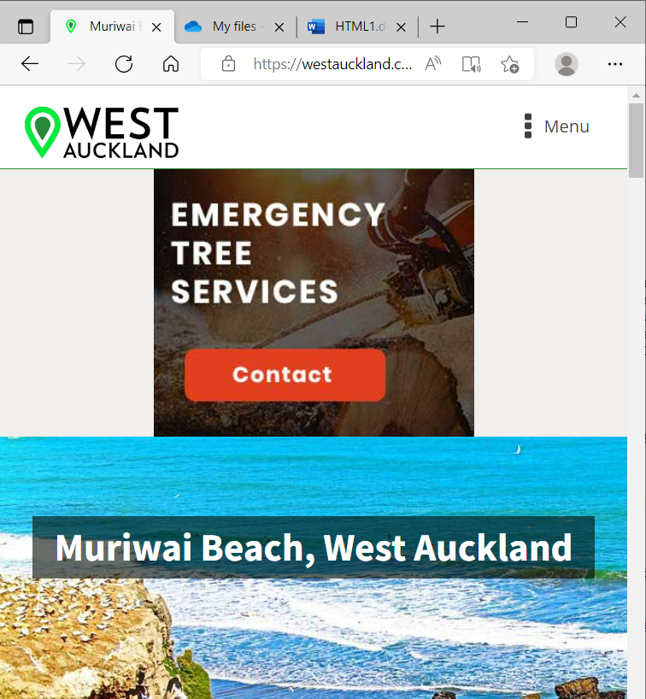

## **src,** **width** and **height** Attributes

The **<img>** tag is used to embed an image in an HTML page. The **src** attribute specifies the path to the image to be displayed.

1. *Copy a .jpg file into the WebClass folder and rename the .jpg file myimage.jpg.*
2. *Add the line <img src="myimage.jpg" width="200" height="250"> to the index.html file as shown below.*

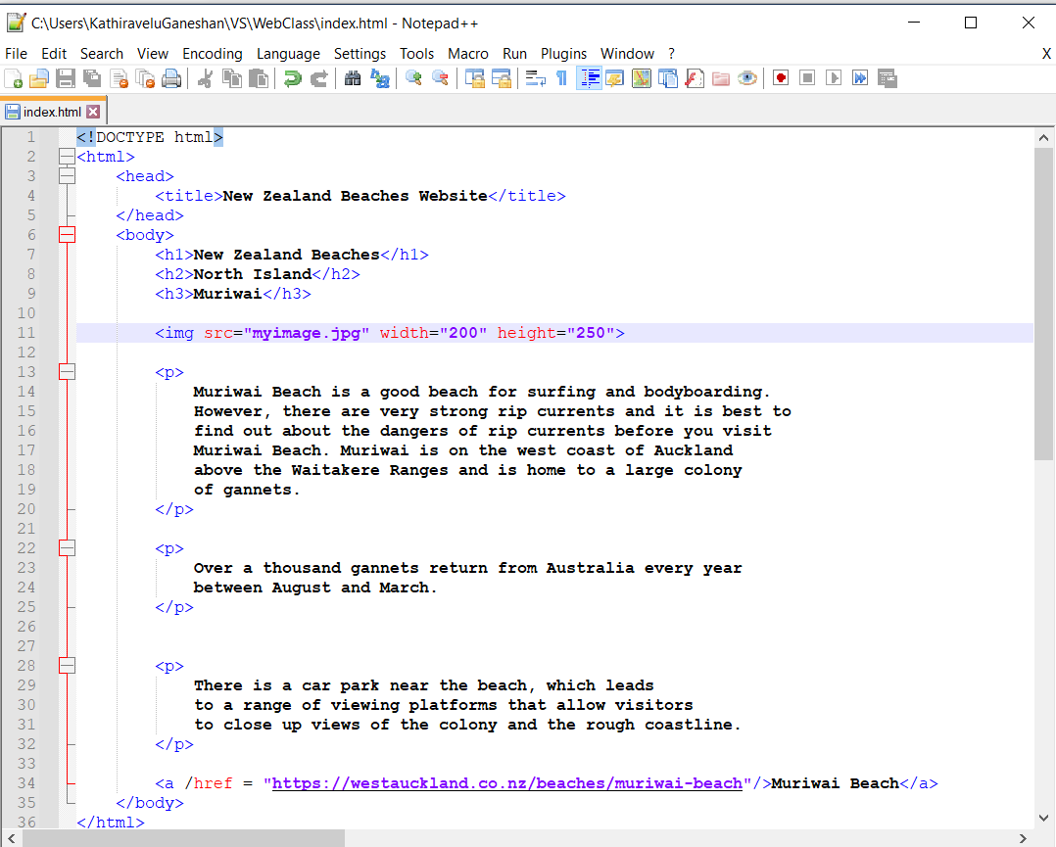

1. *Reload the web page.*

